Clipboard Health Growth Strategy Case

Phillip Choi

1. What was CAC in October?

CAC in October 2022 was $753.78.

Customer acquisition cost consists of all marketing costs divided by the number of customers acquired during a measured period. In this case, marketing costs include a $300 referral bonus, altering the CAC formula:

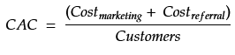

For purpose of this exercise and sake of simplicity, only active accounts opened in October are considered an October acquisition. A customer is labeled October even if their first shift was completed a few weeks later in November, or cases of exposure to a September campaign but ultimately opened with an October campaign. Thus, CAC will continuously change over time, but the difference should be negligible after 2 or 3 months.

After exploring the 3 datasets provided using Excel, the required information for this question was found within the paid marketing data and HCP data. Although SQL is preferred for performing calculations, the two files were analyzed using Pandas dataframes in Python due to the ease in loading csv formats.

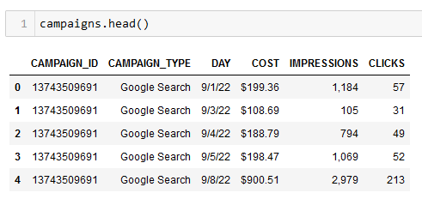
Figure 1. Marketing data after loading in Pandas

The first value obtained in the CAC formula is October’s marketing costs by adding cost of rows with an October date. Proceeding from the raw dataset in fig. 1 to the clean set in fig. 2: checked for inconsistencies like null values, removed $ symbol in cost column, changed datatypes for day and cost column, and filtered out any non-October dates.
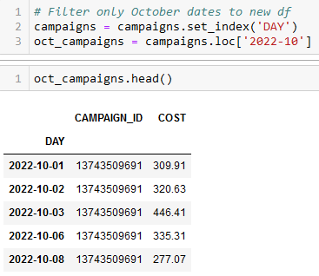
Figure 2. Code reducing to only October dates and the resulting dataframe

Calculating the total amount spent in October campaigns was a simple sum function of all the costs, returning a total of $815,061.30:

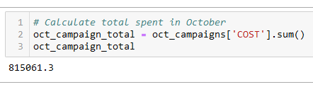
Figure 3. Total spent in October campaigns

Determining both the total cost of referral bonuses and number of customer acquisitions required the HCP dataset. Only accounts that worked a shift can be considered an acquired customer. For purposes of this study, all accounts with a null value in FIRST_SHIFT_TIME are forever inactive and thus removed. From the remaining active accounts, another filter on the CREATED_AT column ensures only customers acquired in October.

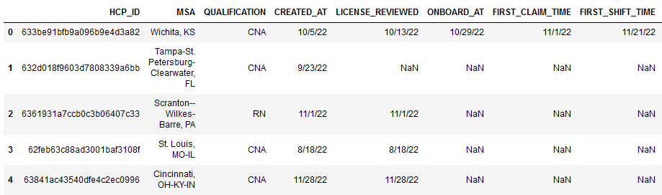
Figure 4. Slice of raw HCP dataset in Pandas

From the example in fig. 4, only the first row is an acquired working customer. Further, because the account was created on 10/5/22, this customer was included in the October CAC calculation. Lastly, a simple Pandas function counted all the non-null values in the REFERRER column to find number of referred accounts.

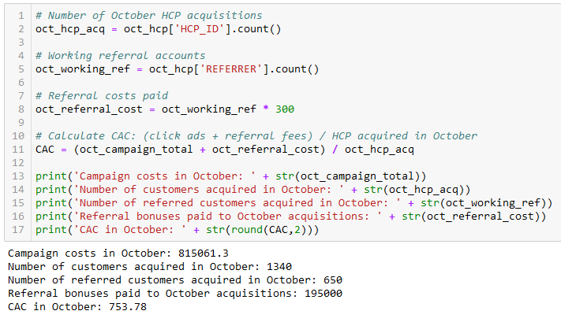
Figure 5. Final CAC calculations

CAC calculation was done in Python. October’s campaign costs were $815,061.30 and the referral program added another $300 in costs for each of the 650 referred customers, or $195,000. Total spent was $1,010,061.30 to acquire 1,340 customers, or $753.78 each.

2. How much would you be willing to increase the referral bonus in Los Angeles and Nashville? Why?

